**INVENTION DISCLOSURE FORM FOR PATENTS**

**Applicant Name-Marwadi University**

1. **Particulars of Inventors**

|  |  |  |  |  |  |  |
| --- | --- | --- | --- | --- | --- | --- |
| Mr./Ms/Dr. | Name (Full) | Department | Designation | Mobile No. | Email | Postal Address |
| Mr. | Dhairya Aundhia | CE |  | 9499882054 | Dhairya,aundhia119887@marwadiuniversity,ac,in | 1-devpara,rajkot |
| Mr. | Kashyap Vekariya | CE |  | 9429039572 | Kashyap.vekariya118570@marwadiuniversity,ac,in | ratanpar |
| Mr. | Yash Dhedhi | CE |  | 9510616758 | Yash.dhedhi120222@marwadiuniversity,ac,in | Saraya, tankara, morbi |

1. **Provide title of the invention:**

Weather forecasting System

1. **In 100 words or less, please provide an abstract or summary of the invention:**

This invention presents a weather forecasting system that provides real-time weather updates, forecasts, and location-based weather data. Using **WeatherAPI via RapidAPI** for weather data and **Nominatim OpenStreetMap API** for geolocation, the system dynamically fetches weather information based on user search or auto-detected location. The frontend is developed in **React.js** with **Tailwind CSS**, while the backend integration utilizes **REST APIs**. The system offers accurate weather information, quick response times, and an intuitive UI, making weather forecasting more accessible and efficient for users.

1. **Detail description of the invention:( Answer to all below are required in detail)**
   1. **Problem the invention is solving**

Current weather forecasting solutions often require manual input, lack real-time updates, or are not user-friendly. Our system provides automatic location-based weather updates and accurate forecasts using external APIs, making it more accessible and efficient.

* 1. **General Utility/application of the invention**

• Provides real-time weather updates for any searched or auto-detected location.

• Helps users plan activities based on weather conditions.

• Useful for travelers, farmers, event organizers, and emergency services needing reliable weather forecasts.

* 1. **Advantages of the invention disclosing about the increased efficiency/efficacy**

Uses RapidAPI’s WeatherAPI for accurate weather data.

Integrates OpenStreetMap’s Nominatim API for seamless location search.

Auto-detects user’s location using Geolocation API.

Responsive UI with React.js & Tailwind CSS.

Displays dynamic weather icons & visuals based on conditions.

* 1. **Best way of using the invention as well as possible variants**

• Users can search for a location or enable location access for automatic weather updates.

• The system retrieves data via WeatherAPI & Nominatim API, displaying temperature, humidity, wind speed, and forecast.

• Variants could include custom styling and additional API integrations for more details like pollution levels or UV index.

* 1. **Working of invention along with Drawing, schematics and flow diagrams if required with complete explanations**
* User Interaction: User searches for a city or enables location services.
* Geolocation Processing: Nominatim API converts the city name to latitude & longitude.
* Weather Data Retrieval: WeatherAPI fetches real-time weather details using coordinates.
* Frontend Display: The React.js frontend processes the data and updates the UI dynamically.
* Dynamic Updates: The system updates weather info every few minutes or upon user action.

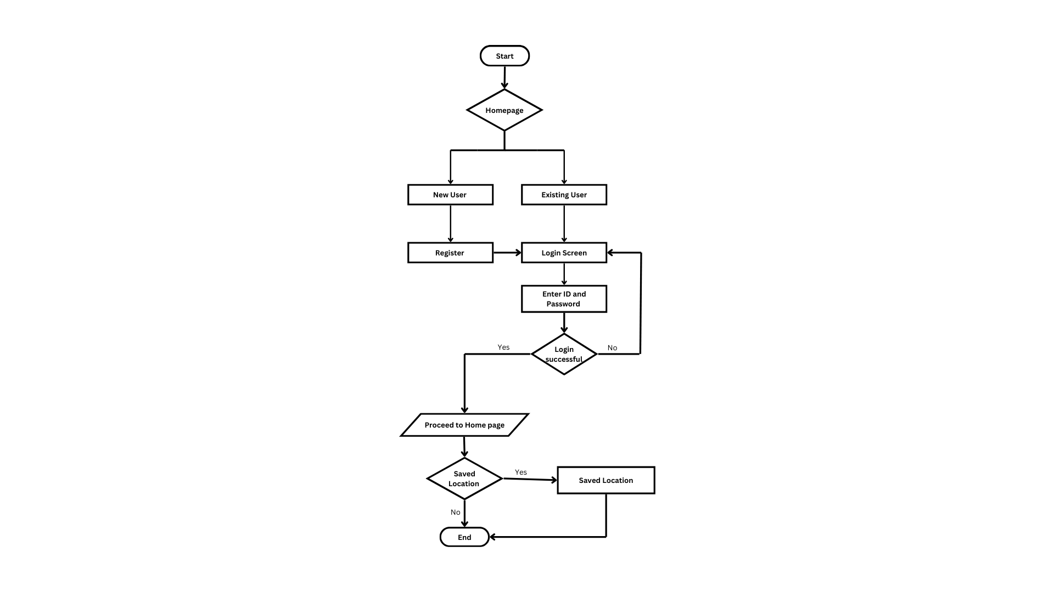

1. **Have you conducted Primary Patent Search? Yes / No (if yes, attach the patent search results)**

No

1. **Existing state-of-the-art and prior arts: (Brief background of the existing knowledge/product/process in the market)**

**Technical Features & Elements of the Invention**

1. Accuweather

**Features:**

* Real-time weather information
* Wind speed, and air quality
* Radar map

**Limitation:**

* Offers extensive data
* Multiple ads

1. Weather

**Features:**

* Day and night temperature predictions
* Wind speed and humidity levels
* UV index

**Limitation:**

* Overwhelming for users looking for quick

1. **List out the known ways about how others have tried to solve the same or similar problems? Indicate the disadvantages of these approaches. In addition, please identify any prior art documentation or other material that explains or provides examples of such prior art efforts.**

|  |  |  |  |
| --- | --- | --- | --- |
| S. No. | Existing state of art | Drawbacks in existing state of art | Overcome (how your invention is overcoming the drawback) |
| 1 | Traditional weather websites (e.g., AccuWeather, The Weather Channel) | Requires manual search, lacks real-time updates, limited location accuracy | Our system provides real-time weather updates based on auto-detected location and dynamic search. |
| 2 | Government meteorology websites | Slow updates, complex UI, not mobile-friendly | Our system offers a modern UI with React.js & Tailwind CSS, ensuring smooth user experience. |

1. **List the Technical features and Elements of the invention along with the Description of your invention from start to end.**

* APIs Used:
  + WeatherAPI via RapidAPI – Fetches real-time weather data.
  + Nominatim API (OpenStreetMap) – Converts city names to coordinates.
  + Geolocation API (HTML5) – Auto-detects user location.
* Technology Stack:
  + Frontend: React.js, Tailwind CSS
  + State Management: React Context API
  + Backend Integration: REST API calls
* Key Functionalities:
  + Real-time weather fetching
  + Dynamic UI updates
  + Search-based and auto-location-based weather results

1. **List out the features of your invention which are believed to be new and distinguish them over the closest technology.**

* Live weather updates using APIs.
* Auto-location weather detection via Geolocation API.
* Minimalist UI with React.js & Tailwind CSS.
* Real-time weather icons & visual updates.
* Highly responsive and mobile-friendly interface.

1. **Has the invention been built or tested or implemented? If yes please provide the Efficiency/Efficacy details of the invention**

* The project is fully functional and tested.
* The system accurately fetches weather data and updates UI dynamically.

1. **Briefly state when and how you first conceived this idea?**

• **Initial Idea:** Conceptualized as a React-based weather app with API integrations.

• **Development Started:** Implemented RapidAPI & OpenStreetMap API integration.

• **Final Testing:** Verified weather updates & UI responsiveness.

1. **Have you sold, offered for sale, publicly used or published anything related to this invention? If yes, please briefly explain the dates and circumstances. List those individuals to whom you have revealed your invention. Were non-discloser documents signed prior to discloser in each case? Please state any deadlines of which you may be aware for filing an application on this invention.**

• Not yet sold or commercially used.

1. **Include any reasons that your invention would not have been obvious to someone of average skill in the art.**

• Unlike traditional weather apps, this system combines multiple APIs (WeatherAPI, Nominatim, Geolocation) for real-time accuracy.

• Faster weather updates and better user experience compared to older weather portals.

1. **Additional comments by inventor (if you want to give more details out of scope of this IDF).**

No

1. **Drawings/Flowchart/Table**

